Problem ?

Algeria is a country where people often struggle to find the services they need, such as doctors, developers, carpenters, and more. Additionally, many people have difficulty finding job opportunities that match their skills and experience. In order to address these challenges, our project aims to create a platform that connects service providers and job seekers across the country.

Through this platform, service providers will be able to advertise their services and search for workers based on location and job type. Users will be able to filter by wilaya, daira, commune, and job to find the most relevant results. Similarly, job seekers will be able to search for opportunities in their area and apply directly through the platform.By providing a centralized platform for connecting service providers and job seekers, we hope to make it easier for people in Algeria to find the services and job opportunities they need. This has the potential to not only improve individual outcomes but also contribute to economic growth and development across the country.

Solution :

To address the challenge of connecting service providers and job seekers in Algeria, our platform offers a comprehensive solution that includes several key features. Users can create a profile and sign up for the platform, which includes a login and sign up system to ensure secure access to the platform. We have also developed a chat system that enables users to communicate with each other via messages, audio, and video calls. Additionally, our platform offers an appointments system that allows service providers and customers to schedule and manage appointments. To build trust and credibility, we have also included a rating and reviews system for services, which enables users to provide feedback and share their experiences with others. they can also share their projects, skills, experiences, certificates, and contact information on their profile, and specify their location. We have created a search system that allows users to filter results by name, job, and location. To enhance the user experience, our platform is available in three languages - Arabic, French, and English - and can be accessed on both web and mobile platforms. Finally, users can post updates and share their thoughts with others, with each post having the ability to receive likes and shares.

Solution as schema :

OUR PLATFORM :

-Create accounts

-Chat System

-Appointment System

-Rating and reviews

-Post and share projects , certificate , skills , experiences

-Contact information

-Search engine

-use Francais , arabic , english .

-Web /Mobile

Client

Job Seekers

Service Providers

Conception :

USECASE :

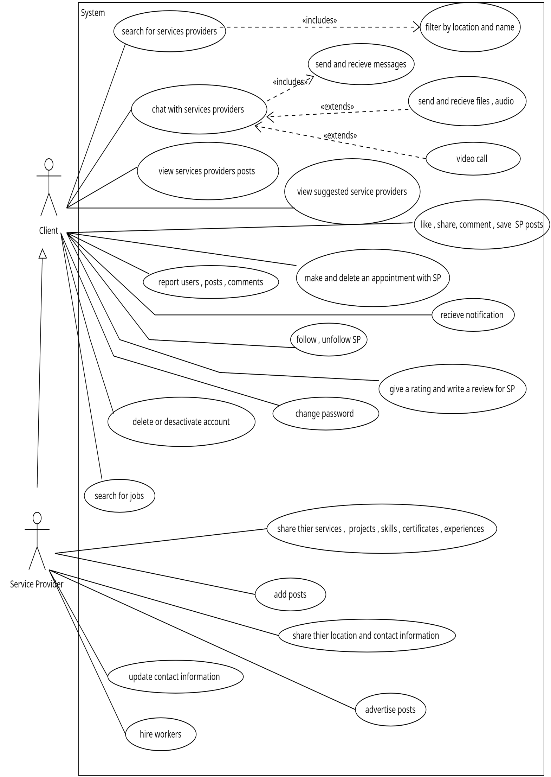

CLASS DI AGRAM :

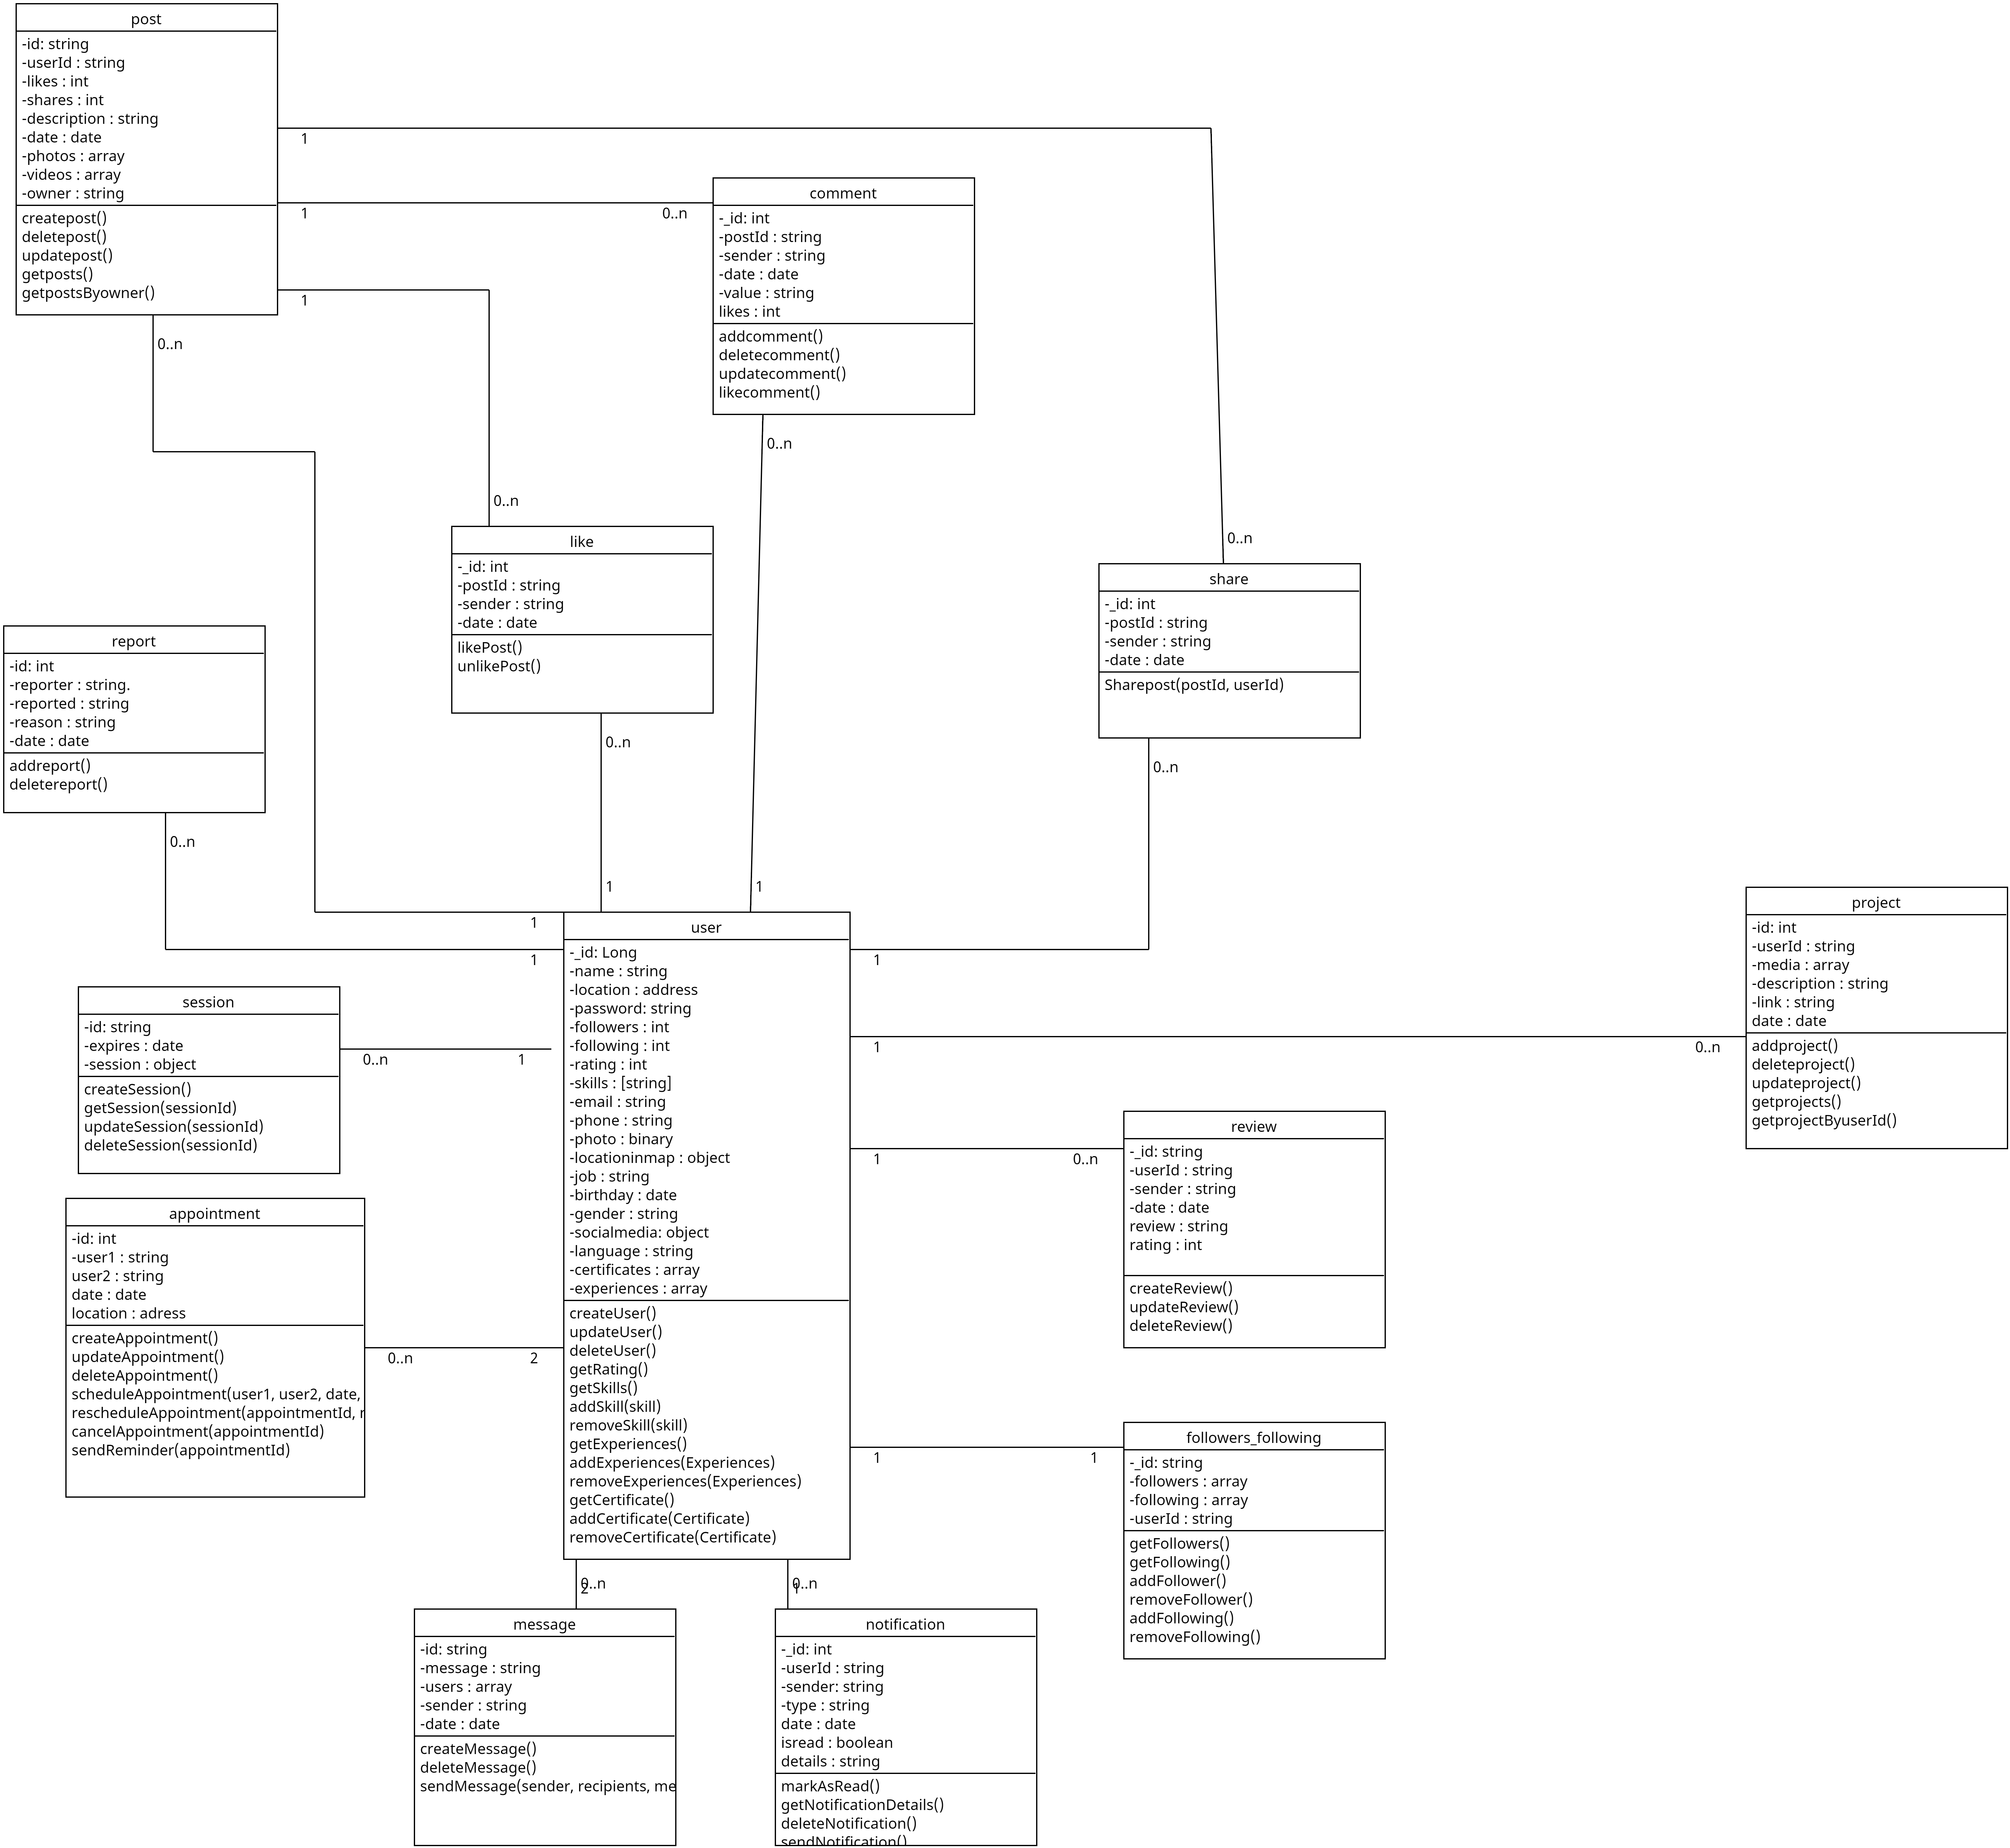

SEQUENCE DIAGRAM :

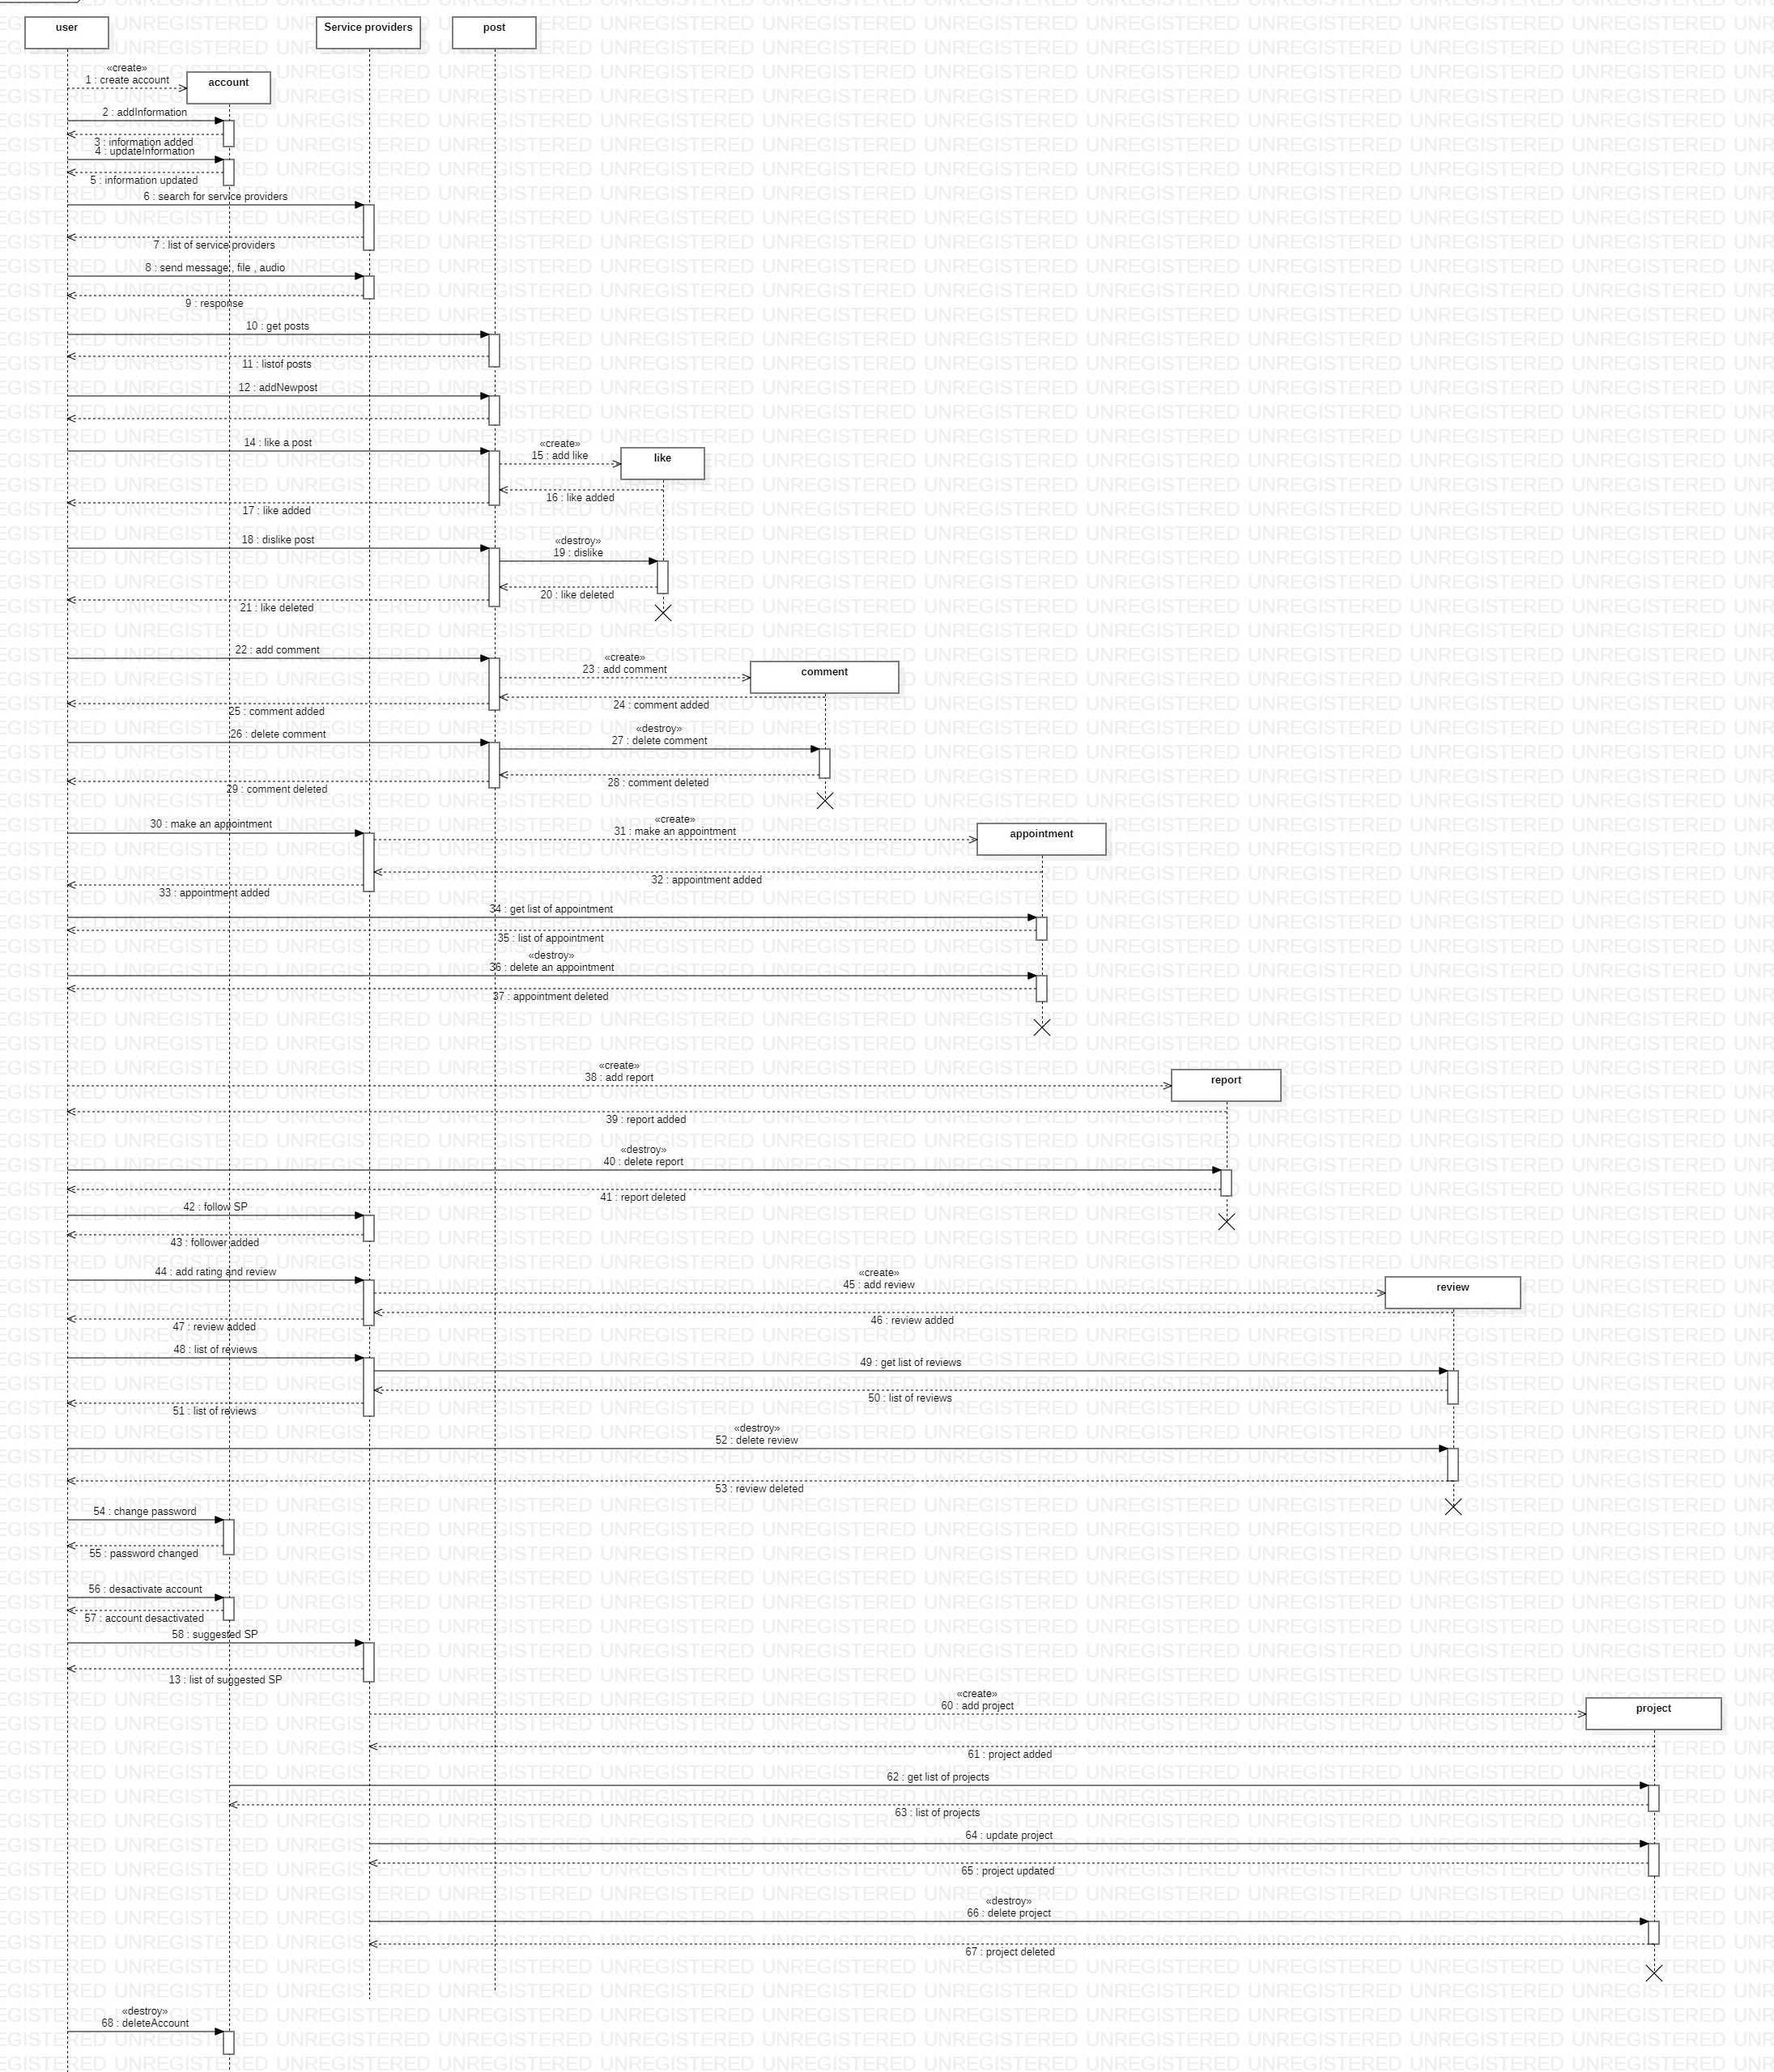

IMPLEMENTATION :

Frontend :

Our platform's frontend will be developed using React, a popular JavaScript library that enables the creation of dynamic, responsive user interfaces. We will utilize a range of other technologies such as React Query, React Hook Form, Material UI, Axios, React Router, and Socket.io to enhance the user experience and provide a seamless frontend. With Material UI, we will be able to create a modern and visually appealing design for the platform, while React Query and Axios will be used to handle data fetching and updating in real-time. React Router will enable smooth navigation throughout the platform, and Socket.io will facilitate real-time communication between users, such as in the chat system. Additionally, our platform will support multiple languages, including Arabic, French, and English, making it more accessible to users from different backgrounds. Overall, our frontend development approach will be focused on creating a user-friendly, responsive, and visually appealing platform that can be accessed on both web and mobile devices.

Backend :

Our platform's backend will be developed using Node.js, a popular server-side JavaScript runtime that enables the creation of fast and scalable web applications. We will utilize a range of other technologies such as Express, Sessions, Mongoose, and Socket.io to provide a secure and robust backend. With Express, we will be able to create a fast and efficient server that can handle multiple requests at once. Sessions will be used to manage user authentication and authorization, while Mongoose will be used as an Object Data Modeling (ODM) library to interact with our MongoDB database. Socket.io will enable real-time communication between users, such as in the chat system. Our backend will be designed with security in mind, implementing various security measures such as encryption, hashing, and input validation to protect against common attacks such as SQL injection and cross-site scripting (XSS). Overall, our backend development approach will be focused on creating a secure, scalable, and reliable platform that can handle a large number of users and provide a smooth user experience.

DATABASE :

our platform's database will be developed using MongoDB, a popular NoSQL database system known for its flexibility and scalability. MongoDB's document-oriented data model will allow us to store and manage a large amount of data in a scalable and efficient way. We will utilize Mongoose, an Object Data Modeling (ODM) library for MongoDB, to define the data schema and handle the interactions between the database and the server. Our database will be designed to store various types of data, such as user profiles, service listings, job postings, chat messages, and media files. We will also implement various data validation mechanisms to ensure that the data stored in the database is consistent and accurate. Our database will be deployed on a cloud-based platform such as MongoDB Atlas to ensure scalability and high availability. We will also implement various backup and disaster recovery mechanisms to ensure data availability and durability. Overall, our database development approach will be focused on creating a scalable and reliable database that can handle a large amount of data and provide fast access to the data stored in it.

COMMUNICATION ( CLENT/SERVER ) :

Our platform's communication between the server and client will be implemented using RESTful APIs, a widely-used architectural style for building web services. RESTful APIs will use HTTP requests to perform various operations on resources, such as GET (fetching data), POST (creating new data), PUT (updating existing data), and DELETE (deleting data). We will utilize the CRUD (Create, Read, Update, Delete) operations to manage our platform's data, enabling users to create, read, update, and delete various resources, such as user profiles, service listings, and job postings. Our RESTful API will be designed with scalability in mind, allowing for easy integration with third-party services and support for multiple client applications, such as web and mobile platforms. To ensure data security, we will implement various authentication mechanisms such as JSON Web Tokens (JWT) and session-based authentication. Our platform's communication between the server and client will be fast, efficient, and reliable, enabling users to interact with the platform seamlessly and perform various operations in real-time.

MOBILE APP :

our platform's mobile application will be developed using Cordova, a widely-used framework that will enable the creation of hybrid mobile applications using web technologies such as HTML, CSS, and JavaScript. With Cordova, we will be able to create a mobile application that runs on both Android and iOS devices, providing a seamless user experience across both platforms. We will utilize a range of other technologies such as React and Material UI to create a visually appealing and user-friendly mobile application. Our mobile application will support a range of features such as user authentication, real-time chat, service listings, job postings, and a search system that will enable users to search for services and jobs based on location and other criteria. We will also integrate support for various media types such as images, audio, and video to enable users to share their projects and skills with others. Additionally, our mobile application will support multiple languages, including Arabic, French, and English, making it accessible to users from different backgrounds. Overall, our mobile development approach will be focused on creating a responsive and user-friendly application that can be easily accessed on a variety of devices and platforms.

Implimentation schema :

\*Node js

\*Express s(API’s)

\*Mongo DB

\*Socket.io

\*Mongoose

\* React js

\*Material UI

\*React Query

\*React Hook Forms

\*Axios

\*React router

\*Yub

\* sochet io

HTTP REQUEST

External APIS

SMS /email ,

image and text validation

CORDOVA SCHEMA :

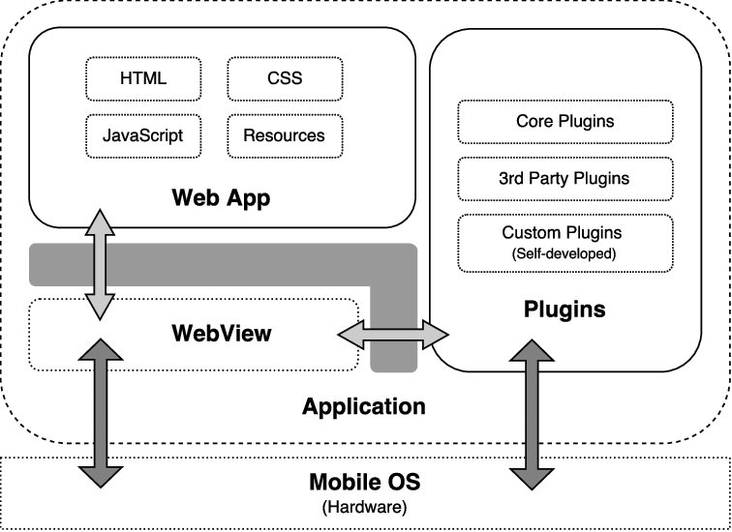

CONCLUSION :

In conclusion, our platform will be designed to address the growing need for a centralized and reliable service provider and job seeker platform in Algeria. We will leverage modern web and mobile development technologies such as React, Cordova, and Node.js to create a responsive, user-friendly, and scalable platform. Our platform will include a range of features such as user authentication, real-time chat, service listings, job postings, search, and media sharing. We will also implement a MongoDB database to store and manage a large amount of data in a scalable and efficient way. Our platform's design and development approach will be focused on creating a reliable, secure, and user-friendly platform that meets the needs of both service providers and job seekers in Algeria. We believe that our platform will have the potential to greatly improve the service provider and job seeking experience in Algeria, and we look forward to continuing its development and growth in the future.